Exercise Questions for Chapter 6: Complex Control Schemes
1. Consider the cascade control system in Fig. Q1.
- Specify 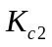 so that the gain margin 1.7 and phase margin 30for the slave loop.
- Then specify 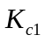 and 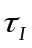 for the master loop using the Ziegler-Nichols tuning relation.
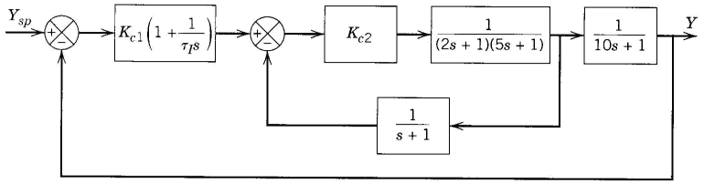
Fig. Q1 Cascade control system

2. A cascade control configuration is sometimes used to separate different objectives of feedback control. For instance, first an inner loop can be used to stabilize the process, and then an outer loop can be used to control the output to track set-point changes and reject disturbances. An example of a cascade control system is shown in Fig. Q2. The process transfer function
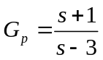
is unstable.
- Determine the maximum range of values for which the inner loop will be stable.
- Now assume = 6 and 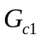 is a PI controller with gain 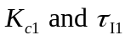. Find values of and such that the closed-loop poles of the transfer function from Y_{sp} to Y(s) are at 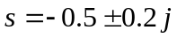.
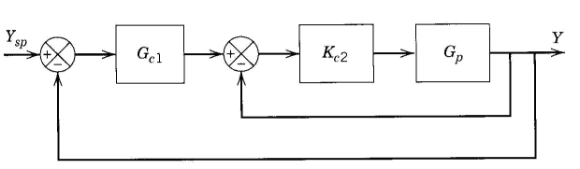
Fig. Q2. Cascade control for unstable process

- It is desired to control liquid level h₂ in the storage tank system shown in Figure Q3 by manipulating flow rate q₃. Disturbance variable q₁ can be measured. Use the information available to do the following:
- Draw a block diagram for a feedforward-feedback control system.
- Derive an ideal feedforward controller based on a steady-state analysis.
- Suppose that the flow-head relation for the hand valve is 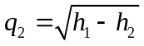. Does the ideal feedforward controller of part (b) change?
Available Information
- The two tanks have uniform cross-sectional areas, A₁ and A₂, respectively.
- The valve on the exit line of Tank 1 acts as a linear resistance with a flow-head relation,
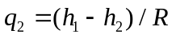.
- The transmitters and control valve are pneumatic instruments that have negligible dynamics.
- The pump operates so that flow rate q₃ is independent of h₂ when the control valve stem position is maintained constant.
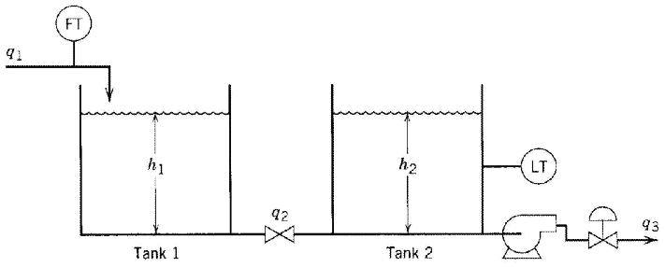
Figure Q3. Storage tank system

4. (a) Figure Q4a shows a feedback control scheme for a blending process that is subject to significant disturbances. It is desired to augment this scheme with feedforward control. Of the four potential locations for the feedforward measurement indicated in the diagram, A, B, C, or D, which would be the best? The θ values noted in the diagram correspond to the average residence time in the indicated hollow pipes.) Justify your answer briefly.
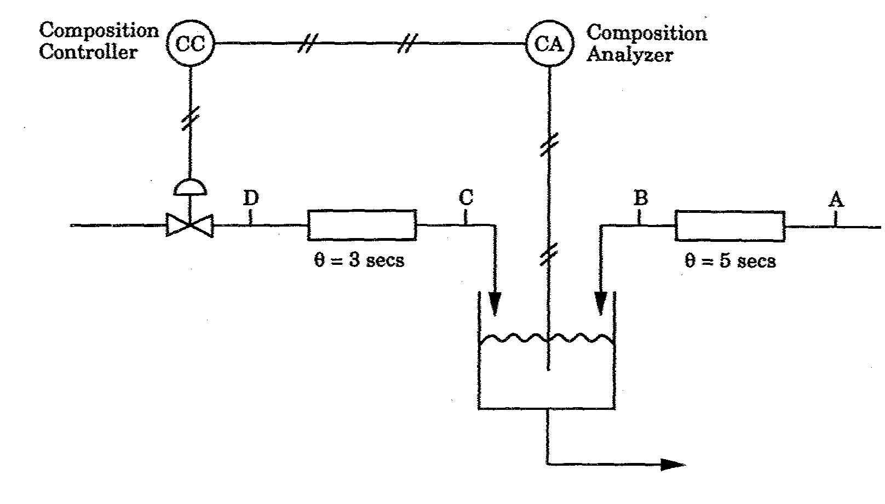
Figure Q4. A feedback control scheme for a blending process
(b) Figure Q4b shows a schematic diagram for a heat exchanger exit temperature control problem. The exit temperature of the process stream is influenced by the steam flowrate into the heat exchanger shell, and by the erratically varying inlet temperature of the process stream. The steam flowrate itself is also subject to erratic fluctuations induced by unsteady, unpredictable, and unmeasured steam supply pressure. Temperature measurements are provided by two temperature sensors and accompanying transmitters indicated as TTI and TT2 in the diagram; and steam flow measurements are provided by a flowmeter and the accompanying flow transmitter; FT, also indicated in the diagram.
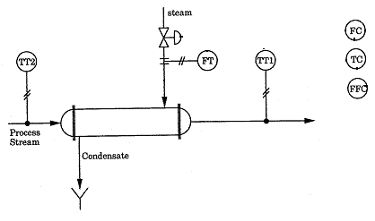
Figure Q4b Schematic diagram of heat exchanger exit temperature control

